Walk in Clinic Service App

Department of Engineering

**University of Ottawa**

Kartik Singhal

Milad Rezaee

Thinh Hong

Matt Ignaczak

December 3rd, 2019

Introduction

The application was developed for the intended idea that people needed to know waiting times at nearby walk-in clinics by using their phones. It also allows users to know the services, address and the open hours of nearby walk-in clinics. The app also allows them to check-in/book appointments at the clinic of their choice. Firebase was used to allow shared data. The app has 3 different users in mind. The first one is the administrator, the walk-in clinics employees, and the patients. The administrator manages all the possible services that are available to the patients by the clinics. The walk-in clinic employee sets a profile for the clinic, sets the hours and address. The patients can search for a walk-in clinic by address, services and by working hours. Also, they can book appointments and get the approximate wait times

Final UMl Diagram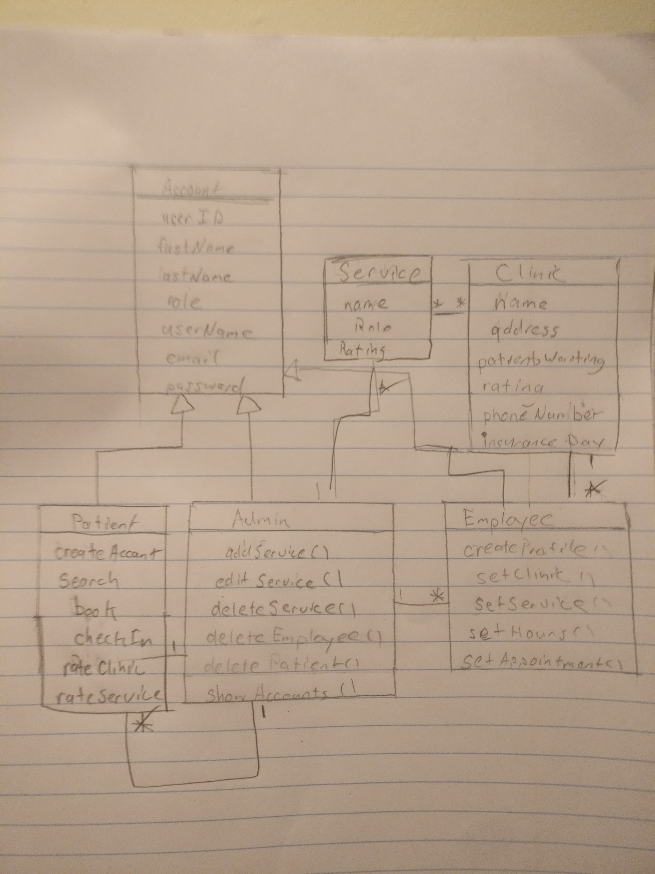

Lessons Learned

* Cultivated the skills and knowledge required to operate Android Studio.
* Learn to develop apps and projects.
* Synchronize data using Firebase.

Contributions

Deliverable 1

|  |  |  |
| --- | --- | --- |
| Name | Contributions | Comments |
| Kartik Singhal | Designed the UML diagram |  |
| Milad Rezaee | Created and developed the StartUp page, Login Page, SignUp page and initial Patient welcome page |  |
| Thinh Hong |  |  |
| Matt Ignaczak |  |  |

Deliverable 2

|  |  |  |
| --- | --- | --- |
| Name | Contributions | Comments |
| Kartik Singhal | Design and finished Employee app |  |
| Milad Rezaee | Created test cases for the deliverable |  |
| Thinh Hong | Finished UMl Diagram |  |
| Matt Ignaczak |  |  |

Deliverable 3

|  |  |  |
| --- | --- | --- |
| Name | Contributions | Comments |
| Kartik Singhal | Designed the test cases for the deliverable |  |
| Milad Rezaee | Designed and developed the Employee services page, clinic information, clinic hours and accepted payments/insurance pages |  |
| Thinh Hong | Finished UMl Diagram |  |
| Matt Ignaczak | UI & fixed some build dependencies |  |

Deliverable 4

|  |  |  |
| --- | --- | --- |
| Name | Contributions | Comments |
| Kartik Singhal | Moved app to MVVM architecture, did dev work on deliverable 4 |  |
| Milad Rezaee |  |  |
| Thinh Hong | Finished UMl Diagram, Did part of deliverable 4 |  |
| Matt Ignaczak | CI and part of delievarble 4 |  |

Screenshoots

Lessons Learned

- Cultivated the skills and knowledge required to operate Android Studio.

- Learn to develop apps and projects.

- Synchronize data using Firebase.

- Need to stick to an architecture for the app.

- Important team building skills

- Develop the knowledge needed to work Android Studio